The OSPAR Commission for the Protection of the Marine Environment of the North-East Atlantic
Introduction
- Regional Seas Conventions facilitate the collaboration and coordination that is essential if countries are to collectively manage the ocean effectively and efficiently. OSPAR, the regional sea convention for the North-East Atlantic, has over 50 years of experience dealing with ocean related issues and a strong track record of managing human activities and protecting and conserving the marine environment.

- Underpinned by a legally binding convention, signed and ratified or approved by all its 16 Contracting Parties, OSPAR has a clear mandate and obligation to protect and conserve the marine environment while using its resources sustainably.

- The increasing use of the ocean and the trans-boundary nature of the marine environment, reinforces the need for regional level bodies, like OSPAR, to help address the triple planetary crisis of climate change, biodiversity loss and pollution.
1967
Grounding of Torrey Canyon – 117,000 tonnes of oil
1969
Leads to establishment of Bonn Agreement for Cooperation in Dealing with Pollution of the North Sea by oil
1972
Convention for the Prevention of Marine Pollution by Dumping from Ships and Aircraft – the OSLO Convention.
1974
Convention for the Prevention of Marine Pollution from land-based sources – the PARIS Convention.
1992
Environment Ministers meet to agree to merge OSLO and PARIS into OSPAR Convention for the Protection of the Marine Environment of the North-East Atlantic
1998
OSPAR Convention adds new Annex to address biodiversity
2025?
OSPAR Ministerial Meeting – what next?

The added value of working through OSPAR
Evidence-based policy
- Addressing the triple planetary crisis of biodiversity loss, climate change and pollution requires evidence-based policies. By working together OSPAR Contracting Parties have access to a much greater pool of experts and other scientific resources to provide the evidence needed to support their national, regional and global ocean related commitments. Collaboration and coordination of monitoring and assessment activities between Contracting Parties:
- saves resources (pooling experts’ knowledge and scientific expertise);
- ensures evidence is provided at ecologically relevant scales (many marine issues are better dealt with at a regional scale);
- allows sharing of latest scientific developments.
- delivers national, regional and global assessment obligations (report once use many times);
- burden sharing of data management systems (spreading the costs between Contracting Parties to minimise costs).
Ecologically relevant
- The marine environment, more so than the terrestrial environment, does not recognise national borders. By working together countries can address issues at the right scale, underpinned by relevant evidence, and therefore increase the chances that measures are successful. For example, marine litter is transported across national borders and around the globe, many marine species are migratory and depend on habitats outside of national borders, chemicals and pollutants flow into the seas from rivers that cross international borders. To understand the impacts of human activities on the marine environment and to develop effective measures countries benefit from working together.
Economically beneficial
- All OSPAR Contracting Parties have national, regional and global commitments to assess the status of the marine environment, to reduce pollution and to take measures to ensure that the ocean is protected and that it can continue to be used sustainably. These commitments are often embedded in legislation. By working together Contracting Parties can significantly reduce the costs of meeting these monitoring and assessment commitments. OSPAR also has a strong track record of working with industry sectors to produce consistent best practice guidance and industry standards that facilitate their operations and reduce red tape and bureaucracy. By sharing expertise, knowledge and resources all Contracting Parties can benefit and keep the costs of delivering on their commitments to a minimum.
- Working at a regional scale also means that Contracting Parties can streamline monitoring programmes so that individually each Contracting Party pays less for its monitoring while maintaining the quality of the data and related assessments.
Who contributes to OSPAR’s work?
- One of the big challenges facing ocean governance is the cross-sectoral nature of many of the issues that need to be addressed. The expansion of offshore renewables is a good example of this. OSPAR provides a ready-made governance framework for dealing with such issues e.g. the Committees dealing with offshore oil and gas and radioactive substances. By working within the OSPAR governance framework, OSPAR brings together experts and policy makers from different Ministries/Departments to manage the activities of those industry sectors while also ensuring Contracting Parties address their environmental commitments.

- The OSPAR Committees and subsidiary bodies provide a one-stop shop for policy makers and experts and external stakeholders through OSPAR’s observer organisations to come together to share common concerns. This existing pool of policy and evidence experts is a valuable resource for Contracting Parties and observer organisations that ensures measures are underpinned by robust evidence and address Contracting Parties’ policy priorities.

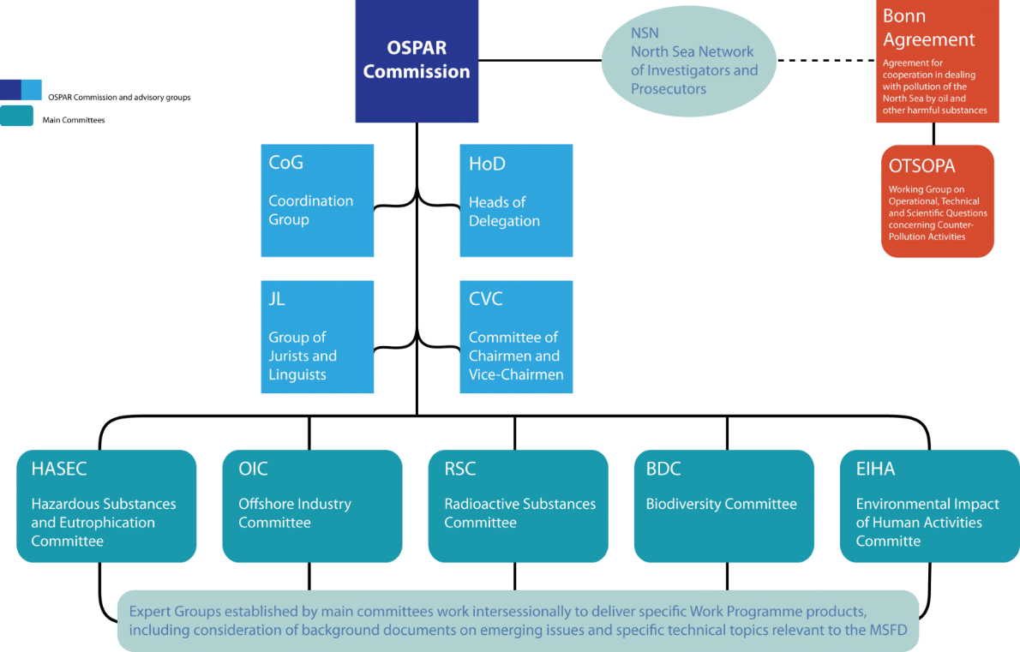

Supporting Contracting Parties that are also EU Member States
- The Marine Strategy Framework Directive (MSFD) is the primary directive of the European Parliament and the Council in the field of marine environmental policy. Like OSPAR, its overall aim is to promote the sustainable use of the seas and conserve marine ecosystems. The MSFD recognises the benefits of working collaboratively and coherently on marine issues and mandates that Member States collaborate in developing their marine strategies, emphasising the importance of cooperation. It highlights the use of regional seas conventions' coordination capabilities to establish marine strategies and conduct assessments, ensuring a comprehensive evaluation of the status of the marine environment.
- Of course, not all Contracting Parties are EU Member States, but they do all share a common marine environment. OSPAR provides an existing platform for regional level coordination and collaboration on shared environmental concerns and a space to develop a consistent approach on sustainable use of the ocean for users of the marine environment.
Data and information availability
- OSPAR is committed to making as much information as possible publicly available. This is delivered through the OSPAR Data and Information Management System (ODIMS) and the OSPAR Assessment Portal OSPAR - Assessments - OSPAR-OAP (Prod) (OAP). The provision of data and information collected by OSPAR represents an important cost saving for OSPAR Contracting Parties. It would cost significantly more if each Contracting Party were to provide the same level of access to data and information at a national level.
- The data is freely available not only to all Contracting Parties but to academic institutions, industry, researchers and the general public.
- The shared development and management of regional databases also provides a significant saving to OSPAR Contracting Parties. It avoids the need for each Contracting Party to manage and host its own data, it ensures a consistent approach and access to a greater pool of data to all Contracting Parties. Examples include:
- Joint databases on marine litter, marine protected areas, riverine inputs and direct discharges;
- Registries for underwater noise, inventories of offshore installations;
- Automated assessment products for eutrophication and hazardous substances;
- Joint monitoring programmes.
International collaboration
- The agreement under the United Nations Convention on the Law of the Sea on the Conservation and Sustainable Use of Marine Biological Diversity of Areas beyond National Jurisdiction (BBNJ Agreement) highlights the importance of collaboration and coordination between international intergovernmental organisations.
- OSPAR is particularly well placed to support its Contracting Parties to implement the BBNJ Agreement: over 40% of OSPAR’s maritime area is in areas beyond national jurisdiction; it is one of the few regional sea conventions with a mandate to take measures in areas beyond national jurisdiction (ABNJ); it has an existing network of marine protected areas (MPAs) in ABNJ; and has experience of many years of collaboration and coordination with other legally competent international bodies and frameworks, in particular with the North-East Atlantic Fisheries Commission.
- OSPAR also provides a mechanism by which its Contracting Parties can deliver on their global biodiversity commitments. More than 143 countries participate in one or more of the 18 existing Regional Seas Conventions and Action Plans (RSCAPs) around the world. Working with the other RSCAPs, OSPAR can help to build capacity, share knowledge and experiences that help countries to deliver the 2030 Agenda for Sustainable Development and, in particular the commitment to conserve and sustainably use the oceans, seas and marine resources, as reflected in Sustainable Development Goal 14.
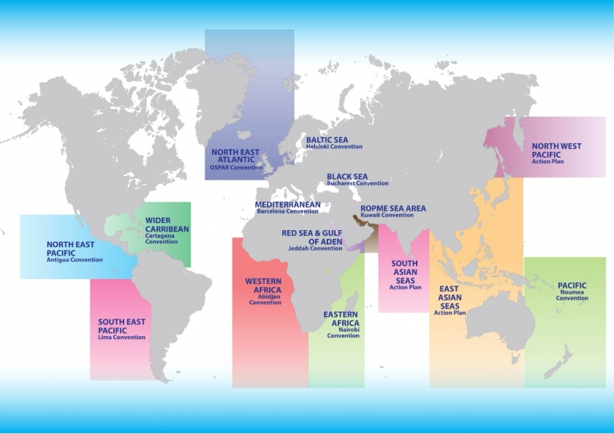

What is OSPAR?
- The OSPAR Commission for the Protection of the Marine Environment of the North-East Atlantic (OSPAR) is the regional sea convention for the entire North-East Atlantic. It was established under the OSPAR Convention for the Protection of the Marine Environment of the North-East Atlantic, a legally binding instrument regulating international cooperation on environmental protection in the North-East Atlantic.
- The 16 Contacting Parties are: Belgium, Denmark, European Union, Finland, France, Germany, Iceland, Ireland, Luxembourg, The Netherlands, Norway, Portugal, Spain, Sweden, Switzerland and United Kingdom.
- Through OSPAR, Contracting Parties collaborate to assess the state of the North-East Atlantic and to develop and implement the necessary actions, individually and collectively to achieve its vision of:
“a clean, healthy, and biologically diverse North-East Atlantic Ocean, which is productive, used sustainably and resilient to climate change and ocean acidification.”
- Over 60 organisations are accredited as formal OSPAR Observer organisations. These organisations play an essential role in the work of the OSPAR Commission. They include other intergovernmental organisations working in similar fields, environmental non-governmental organisations, industry and trade organisations and organisations of regional and local authorities.
- The OSPAR Convention was concluded in Paris on 22 September 1992 and entered into force on 25 March 1998. It combines and updates the 1972 Oslo Convention for the prevention of marine pollution by dumping from ships and aircraft and the 1974 Paris Convention for the prevention of marine pollution from land-based sources. The name is a combination of "Oslo" and "Paris".

The OSPAR Maritime Area
- 5 Regions
- approximately 162 000 km of coastline;
- covers over 13.5 million km²
- approximately 40% is in Areas Beyond National Jurisdiction (ABNJ)
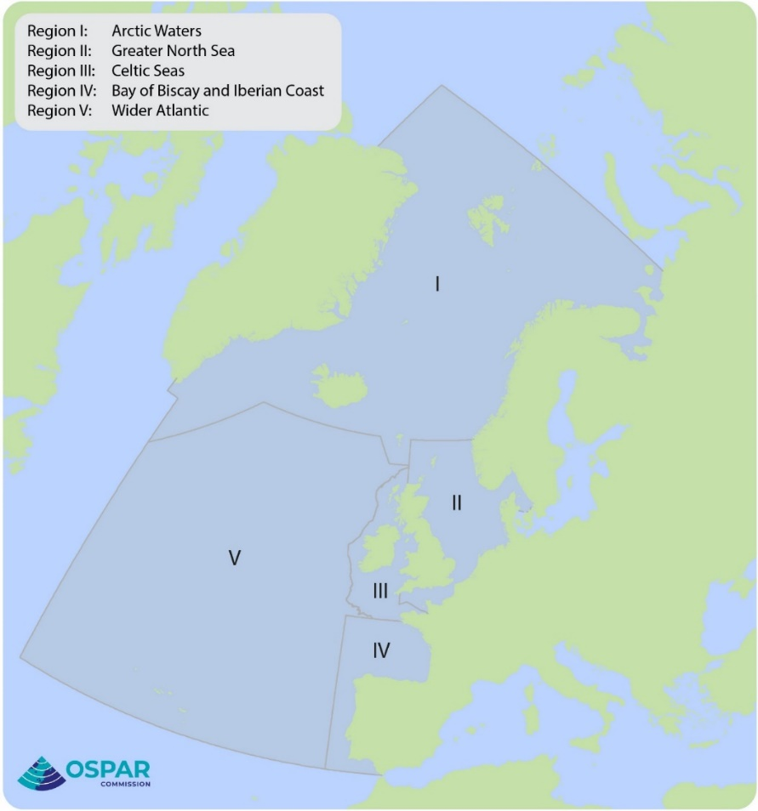

Principles
- The OSPAR Commission works under the umbrella of customary international law as codified by the 1982 United Nations Convention on the Law of the Seas (UNCLOS), especially in Part XII and Article 197 on the global and regional cooperation for the protection and preservation of the marine environment. The OSPAR Convention recognises the jurisdictional rights of states over the seas and the freedom of the High Seas, and, within this framework, the application of main principles of international environmental policy to prevent and eliminate marine pollution and to achieve sustainable management of the maritime area.
- The work of the OSPAR Commission is guided by the ecosystem approach to an integrated management of human activities in the marine environment. This is supported by a general obligation of Contracting Parties to apply:
- The precautionary principle;
- The polluter pays principle;
- Best available techniques (BAT) and best environmental practice (BEP), including clean technology.
- the principle that preventive action should be taken;
- the principle of sustainable development, including circular economy approaches; and
- the principle that priority is given to environmental damage being rectified at source.
What does OSPAR do?
- OSPAR Contracting Parties have been successfully collaborating and cooperating to implement measures to protect the marine environment and ensure it is used sustainably for over 50 years. The Convention includes a general obligation to:
- prevent and eliminate pollution;
- protect the maritime area against the adverse effects of human activities so as to safeguard human health; and
- conserve marine ecosystems and restore, where practicable, marine areas which have been adversely affected.
- In addition to the obligations and duties set out in the articles and annexes of the Convention, Contracting Parties may adopt legally binding Decisions and non-binding Recommendations prescribing collective and national actions. The Convention also requires the Contracting Parties to undertake regular assessments of the marine environment. The latest of these is the Quality Status Report 2023 - OSPAR-OAP (Prod) published in 2023.

- OSPAR’s programme of work and priorities are set out in its North-East Atlantic Environment Strategy 2030. The NEAES 2030 is the means by which OSPAR’s 16 Contracting Parties will implement the OSPAR Convention until 2030. It sets out 12 strategic objectives to achieve:
- clean seas;
- biologically diverse and healthy seas;
- productive and sustainably used seas; and
- seas resilient to the impacts of climate change and ocean acidification.
The strategic objectives are implemented through a series of operational objectives and tasks are implemented by the OSPAR Contracting Parties.
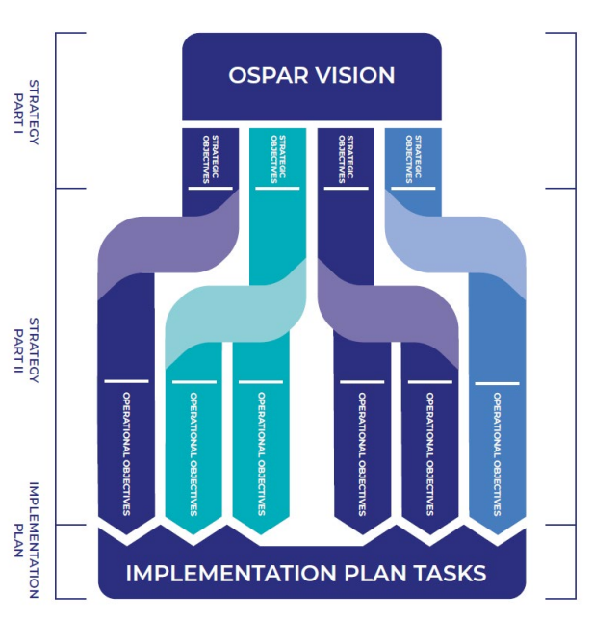
The OSPAR Acquis: Decisions, Recommendations and Agreements
- The OSPAR Acquis: Decisions, Recommendations & Agreements is the accumulated body of OSPAR measures and actions. Taken together the OSPAR Decisions, Recommendations and Agreements constitute a significant contribution to the effective management of the North-East Atlantic. Some of the measures go back over several decades with their origins in the Oslo or Paris Conventions and have contributed to reducing marine pollution.
- OSPAR is often a “first mover” on new and emerging issues, being the first to identify new pressures and develop actions, which are then taken up by other authorities, or organisations.
Examples of OSPAR measures:
- Recommendations on the protection and conservation of biodiversity identified for priority action with programmes of action adopted for 40 species and 18 habitats;
- Decisions and Recommendations on the designation and management of 8 collectively designated Marine Protected Areas in ABNJ covering more than 1 million km²;
- Agreement: Development of a Regional Action Plan for marine birds;
- Recommendations: risk-based approach for the management of produced water discharges from the offshore oil and gas industry to complement the OSPAR harmonised mandatory control system for offshore chemicals;
- Decision: prohibition on the dumping or leaving in place of disused offshore installations;
- Recommendations on implementation of measures to apply Best Available Techniques and Best Environmental Practice in nuclear facilities resulting in a reduction of discharges from the nuclear sector;
- Decisions leading to successful phasing out of all mercury cell chlor-alkali plants in the OSPAR maritime area;
- Agreement on development and implementation of the Regional Action Plan on marine litter;
- Agreement: OSPAR’s List of Chemicals for Priority Action identifies those substances which are considered to be a threat to the marine environment and the actions that OSPAR should take to minimise those threats.

Bright spots: evidence of OSPAR success
- Quality Status Report 2023: a comprehensive assessment of the environmental health and status of the North-East Atlantic Ocean and the human activities interacting with it
- Mercury inputs via rivers approximately halved between 1990 - 1995 and 2010 - 2014 in Regions II, III and IV and have continued to decrease since then. Over the same timeline, air inputs from air reduced by approximately one third.
- For Regions I – IV of the OSPAR Maritime Area nitrogen inputs from atmospheric nitrogen deposition, notably NOx, decreased by about 25% between 1990 and 2019.
- Waterborne phosphorus inputs to Regions I – IV have more than halved since 1990 and continue to decrease.
- OSPAR's marine litter assessments show some positive signs that measures might be working. The quantities of litter found on OSPAR beaches between 2015-2020, and of floating litter in the North Sea between 2009-2018, have decreased.
- Environmental concentrations of radioactive substances are close to historical levels throughout the OSPAR maritime area, with progressive and substantial reductions seen in discharges from the nuclear sector over the period from 1995 to 2018. No increases in discharges of radioactive substances from the oil and gas sub-sector have occurred.
- There has been a decrease in discharges of chemicals that contain hazardous substances and oil in produced water from offshore oil and gas installations since 2010.
- Discharge of untreated oil-based cuttings has ceased and the level of oil contamination has decreased over most of the OSPAR maritime area.
- By 1 October 2023, the OSPAR Network of MPAs comprised 597 MPAs, including 8 MPAs collectively designated in ABNJ. All MPAs have a total surface area of 1 473 100 km², covering 10.9% of the OSPAR maritime area. Therefore, by designating more than 10% of marine and coastal waters as MPAs, OSPAR has achieved Aichi Biodiversity Target 11 of the United Nations Convention on Biological Diversity (CBD).
Annex II
The added value of working through OSPAR at a glance
Evidence-based policy: OSPAR Contracting Parties have access to a much greater pool of experts and other scientific resources to provide the evidence needed to deliver national, regional and global ocean commitments.
Ecologically relevant: the marine environment does not recognise national borders. By working together countries can address issues at the right ecological scale to ensure measures are successful.
Economically beneficial: by working together Contracting Parties can significantly reduce the costs of monitoring and assessment. OSPAR provides a “one-stop shop” and level playing field for industry sectors.
Existing governance framework: OSPAR provides a ready-made, cross-sectoral governance framework for dealing with issues e.g. offshore renewables, offshore oil and gas and radioactive substances. Brings policy makers, experts and external stakeholders together to share common concerns. This existing pool of policy and evidence experts is a valuable resource for Contracting Parties and observer organisations.
Supporting Contracting Parties that are also EU Member States: OSPAR EU Member States benefit from the collaboration and coordination it provides to deliver their MSFD obligations. Non-EU Contracting Parties share a common marine environment. OSPAR provides regional level coordination and collaboration on shared environmental concerns and a space to develop a consistent approach.
Data and information: all OSPAR data is freely available through the OSPAR Data and Information Management System (ODIMS) and OSPAR Assessment Portal. The provision of data and information collected by OSPAR represents an important cost saving for OSPAR Contracting Parties. It would cost significantly more if each Contracting Party were to provide the same level of access to data and information at a national level.
Share databases: development and management of regional databases also provides a significant saving to OSPAR Contracting Parties. It avoids the need for each Contracting Party to manage and host its own data, it ensures a consistent approach, and access to a greater pool of data to all Contracting Parties.
International collaboration: OSPAR provides a valuable mechanism by which its Contracting Parties can support the delivery of their global commitments on SDG 14, CBD Global Biodiversity Framework and the BBNJ Agreement as well as working with other RSCAPs to build capacity, share knowledge and experiences.

